Name: Muhammad Uzair

Roll No. L1F18BSCS0311

Section: H

Database

Graded Lab 10

Task 1

select concat(firstname,' ',lastname) as EmployeeFullName

from employees

inner join offices

using(officeCode)

inner join customers

on offices.city = customers.city;





Task 2

select count(\*) from customers

inner join orders

on customers.customerNumber = orders.customerNumber and orders.status = 'shipped';



Task 3

select avg(amount) from payments

where paymentdate >= '2004-11-03' and paymentdate <= '2004-11-14';



Task 4

select distinct customerName from customers

where customerNumber IN (select payments.customernumber from payments where payments.amount > (select avg(amount) from payments));





Task 5

select customerName from customers

where customerNumber NOT IN (select orders.customerNumber from orders);

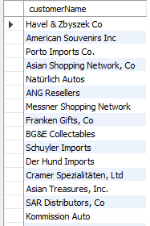

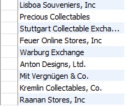

Task 6

select sum(quantityOrdered) as TotalQuantityOrdered,

(select productName from products where products.productcode = orderdetails.productCode) as ProductName

from orderdetails

group by productCode;

